Project Planning Phase
Project Planning Template (Product Backlog, Sprint Planning, Stories, Story points)

Date | 05 October 2026
Team ID | SWTID-2026-4248
Project Name | LearnMate AI StudyBuddy
Maximum Marks | 5 Marks

Product Backlog, Sprint Schedule, and Estimation (4 Marks)
Use the below template to create product backlog and sprint schedule
Sprint | Functional Requirement (Epic) | User Story Number | User Story / Task | Story Points | Priority | Team Members
Sprint-1 | Registration | USN-1 | As a student, I can register by entering my name, email and password so that my account is created securely. | 3 | High | Ranganathan V G
Sprint-1 |  | USN-2 | As a user, I receive an access token and a refresh token when I register so that I am signed in immediately. | 2 | High | Ranganathan V G
Sprint-1 | Login | USN-3 | As a registered user, I can log in with my email and password so that I can use the AI features. | 3 | High | Ranganathan V G
Sprint-1 |  | USN-4 | As a user, I can refresh my session with my refresh token and log out so that my account stays secure. | 3 | Medium | Ranganathan V G
Sprint-1 | Authorization (RBAC) | USN-5 | As a user, I can access private APIs only with a valid Bearer token so that my data is protected. | 3 | High | Ranganathan V G
Sprint-1 |  | USN-6 | As an administrator, I have role-based access so that admin-only routes are restricted to admins. | 3 | High | Vinu N
Sprint-1 | Security | USN-7 | As a user, I want my password stored in encrypted form so that my credentials cannot be misused. | 3 | High | Ranganathan V G
Sprint-2 | Study Material Management | USN-8 | As a student, I can upload a .txt, .md or .pdf study file with an optional title so that it can be used for AI generation. | 5 | High | Vikram C
Sprint-2 |  | USN-9 | As a student, I can list all my uploaded materials so that I can pick one to study. | 3 | High | Vikram C
Sprint-2 |  | USN-10 | As a student, I can open one material to see its content and saved AI results. | 3 | Medium | Vikram C
Sprint-2 |  | USN-11 | As a student, I can delete a material I no longer need. | 3 | Medium | Vikram C
Sprint-2 | Database | USN-12 | As a developer, I can connect the API to MongoDB and define User and Material schemas so that data is stored reliably. | 3 | High | Vikram C
Sprint-2 |  | USN-13 | As a student, I get a clear error for invalid uploads and the temporary file is cleaned up. | 3 | Medium | Vikram C
Sprint-3 | AI Summary | USN-14 | As a student, I can generate a concise bullet-point summary of a material so that I can revise quickly. | 5 | High | Daniel Vasan S
Sprint-3 | AI Flashcards | USN-15 | As a student, I can generate a chosen number of flashcards from a material for active recall. | 5 | High | Daniel Vasan S
Sprint-3 | AI Quiz | USN-16 | As a student, I can generate a multiple-choice quiz to test my understanding. | 5 | High | Daniel Vasan S
Sprint-3 | AI Study Plan | USN-17 | As a student, I can generate a day-wise study plan from my goal, hours per day and number of days. | 5 | High | Daniel Vasan S
Sprint-4 | Admin Management | USN-18 | As an administrator, I can view all registered users (without passwords) to monitor the platform. | 3 | Medium | Vinu N
Sprint-4 |  | USN-19 | As an administrator, I can delete a user together with all their materials. | 4 | Medium | Vinu N
Sprint-4 |  | USN-20 | As an administrator, I can view platform statistics (total students and materials). | 3 | Low | Vinu N
Sprint-4 | Testing & Documentation | USN-21 | As a tester, I can verify every API in Postman so that the system is validated before release. | 5 | High | Vinu N
Sprint-4 |  | USN-22 | As a team, we prepare the complete project documentation and phase-wise templates. | 5 | Medium | Ranganathan V G

Project Tracker, Velocity & Burndown Chart: (4 Marks)
Sprint | Total Story Points | Duration | Sprint Start Date | Sprint End Date (Planned) | Story Points Completed (as on Planned End Date) | Sprint Release Date (Actual)
Sprint-1 | 20 | 6 Days | 07 Sep 2026 | 12 Sep 2026 | 20 | 12 Sep 2026
Sprint-2 | 20 | 6 Days | 14 Sep 2026 | 19 Sep 2026 | 20 | 19 Sep 2026
Sprint-3 | 20 | 6 Days | 21 Sep 2026 | 26 Sep 2026 | 20 | 26 Sep 2026
Sprint-4 | 20 | 6 Days | 28 Sep 2026 | 03 Oct 2026 | 20 | 03 Oct 2026

Velocity:
For LearnMate AI StudyBuddy the sprint duration is 6 days and the team velocity is 20 story points per sprint (80 points over 4 sprints). Average velocity (AV) per day = Sprint velocity / Sprint duration = 20 / 6 ≈ 3.33 story points per day.


Burndown Chart:
A burn down chart is a graphical representation of work left to do versus time. It is often used in agile software development methodologies such as Scrum. However, burn down charts can be applied to any project containing measurable progress over time.
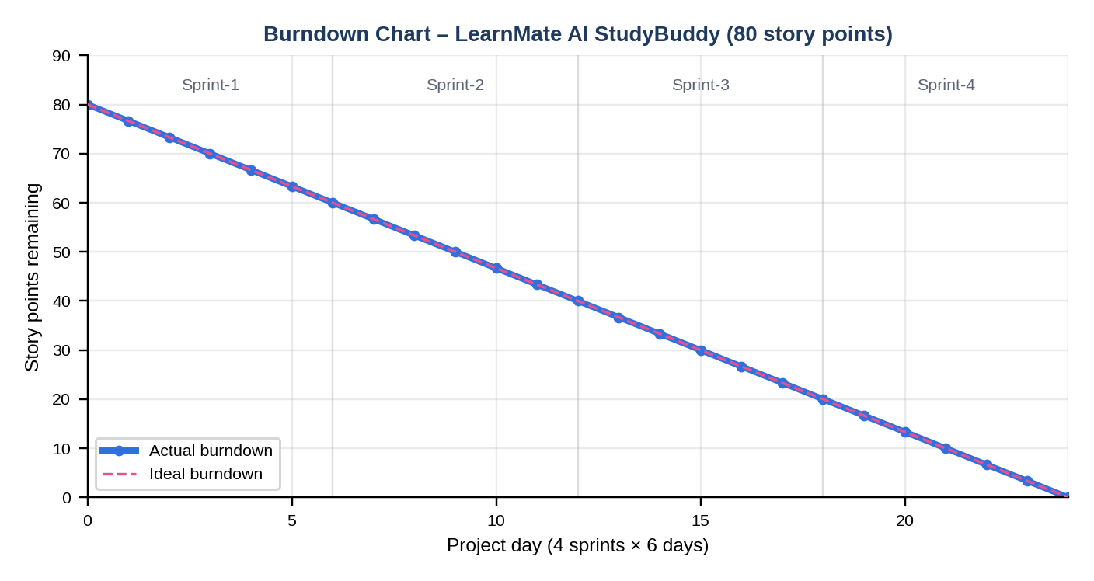

https://www.visual-paradigm.com/scrum/scrum-burndown-chart/
https://www.atlassian.com/agile/tutorials/burndown-charts

Reference:
https://www.atlassian.com/agile/project-management
https://www.atlassian.com/agile/tutorials/how-to-do-scrum-with-jira-software
https://www.atlassian.com/agile/tutorials/epics
https://www.atlassian.com/agile/tutorials/sprints
https://www.atlassian.com/agile/project-management/estimation
https://www.atlassian.com/agile/tutorials/burndown-charts

